[Landing/Welcome page, background colour: lapis lazuli with specks of gold; text colour for the Welcome’ banner: yellow gold; text colour for the page text: light blue/turquoise; effects: parallax scrolling (i.e. the text appears to move faster than the background image)
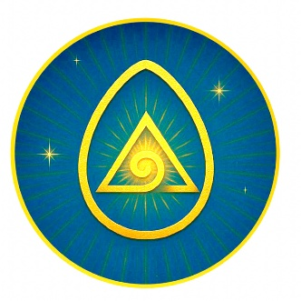
WELCOME TO TESoul’RA

TEMPLE OF EMBODIED SOUL
REMEMBERANCE & ALCHEMY
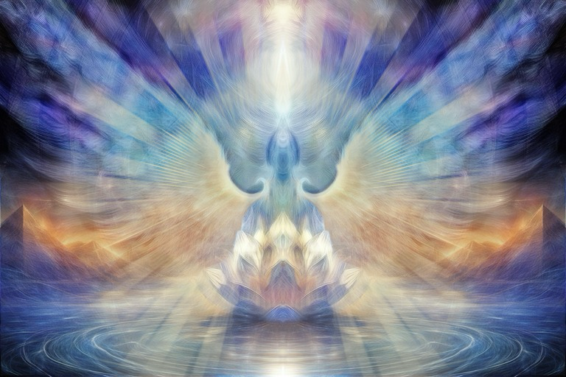
Welcome to TESoul’RA -Temple of Embodied Soul Remembrance & Alchemy
Why Temple? The space I create in my healing sessions is a sacred container, a temple, for the restoration of your body and spirit.
Why Embodied Soul? For the Soul to have truly joyous and harmonious experiences in this physical realm, it needs to be anchored into and aligned with its physical vessel – the body.
Why Remembrance? The greatest awakening occurs when we remember that we are eternal beings of pure love and light having this earthly experience to expand our wisdom and compassion. This remembrance changes everything.
Why Alchemy? The deepest and most transformative healing occurs when we transmute all we have suppressed, denied, judged as negative or painful back into unity and wholeness.
About me

There are only two ways to live your life.
One is as though nothing is a miracle.
The other is as though everything is a miracle.

Elbert Einstein
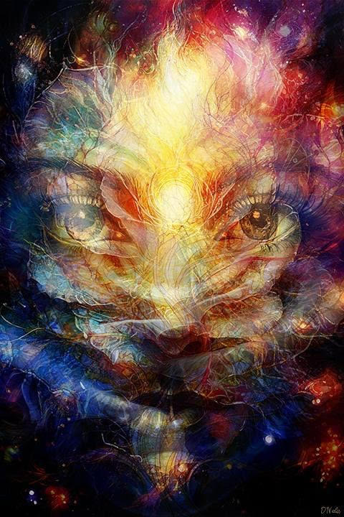

Welcome to my website, where you will find my healing offerings.
I am an energy healer, channel, metaphysics teacher, and experienced mindfulness instructor.
I practice healing under the name T’iam’arhat. This name was revealed to me as a higher aspect of myself in 2016, when I had a spontaneous initiation into Sekhem energy. I did not know the word at the time; it was given to me in meditation.
Even though my professional path started in science, I have always been drawn to energy healing. I tried many different energy healing approaches as a client in my 20^{s} and 30^{s}. In 2013, I did my first formal energy healing training in a modality called Bi-Aura Therapy. I received my certification as a Level 2 Sekhem energy healer in 2024 and completed Level 3 Sekhem Self-Mastery course in 2025.
Science and spirituality have never stood in opposition for me – they are different ways of exploring the mysteries of life and consciousness. In my healing sessions, I combine the scientific understanding of the function and structure of the human brain and body, metaphysical knowledge, intuitive guidance, and channelled information. My approach to energy healing rests on attuning myself to being a pure and clear channel of my Higher Self, the client’s Higher Self, and the Highest Beings of Light who assist with the sessions. Hence, each session is bespoke and fluid, guided by the needs of the client’s Soul.
In addition to Sekhem energy, I use sound and light language for healing and activations in my sessions.
I offer both in-person and distant healing sessions.

What is energy healing
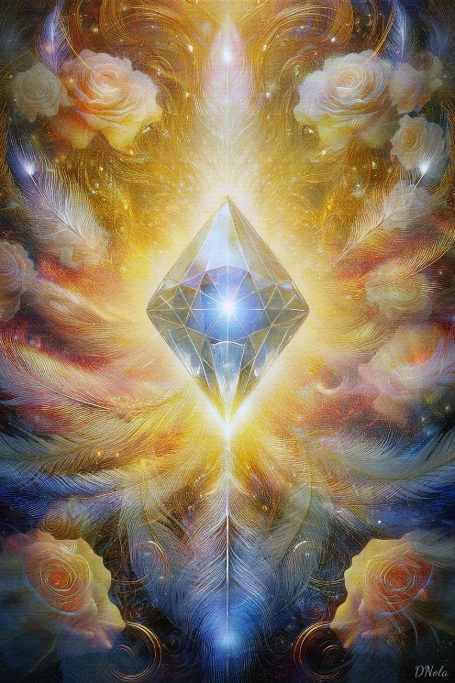

When a living system is suffering from ill health, the remedy is found by connecting with more of itself
Francisco Varela
The mainstream western medicine is based on the principles and laws of Newtonian physics – one billiard ball heating another to exert an effect (pharmacotherapy is a perfect example). All energy healing modalities are based on the principles or laws of quantum physics, which involve fields, vibrations, and frequencies. What we perceive as ‘solid’ matter is the condensation (particles) of the energy fields (waves) that vibrate at different frequencies (speed). EVERYTHING in the Universe, ABSOLUTELY EVERYTHING, vibrates. This is basic physics, not just a New Age notion.
Many things can occur within an energy healing session. However, the main principle rests on a healer serving as a conduit for and an amplifier of the higher energy frequencies, thus ‘lifting’ up the client’s energy field to a higher frequency, similar to how one tuning fork creates resonance in another tuning fork. The healer would also clear old, stagnant and distorted energies, allowing the space for the new pure energies to come in as well as facilitating alignment and integration of these energies in the physical and subtle bodies, including emotional, mental, and spiritual.
Clearing, shifting to higher energy frequencies, and realigning the client’s physical and subtle bodies potentise the client’s energy field, ‘reminding’ it of the coherent vibrational state that is most optimal for health and well-being. This in turn can lead to the resolution of health issues, both physical and psychological.
Both in-person and distant healing sessions can be equally effective. In a distant energy healing session, the healer and client are connected through conscious intention and energetic awareness. This connection creates an informational link, allowing the healer to "tune in" to the client’s energy field, even if they’re on the other side of the world. The healer can then sense imbalances and facilitate shifts, much like sending a signal across a wireless network, except the network in this case is the conscious energy field. Nothing is lost in terms of efficacy, and in some cases even gained, as the healer is able to tune in even deeper without being distracted by the physically of a client’s body. Having said that, whenever practically possible, it is advantageous to have at least your first session with me in person as I am able to use more tools.
What is Sekhem energy
Sekhem is an ancient Egyptian word for the universal vital life-force energy. Since its literal translation is “power” or “might”, it is often referred to as “Power of Powers”. In ancient Egyptian cosmology it is connected to and protected by Sekhmet – a Lion-headed Goddess who transmutes ego-negativity and distorted energies back into the purity of one’s Essence Being as Divine Light, so we can rise as the Phenix, reborn and renewed, to actualise our highest Soul potential. Sekhmet’s healing returns us to the state of personal empowerment, Soul sovereignty, and spiritual warrior, whose weapon is fearless unconditional love and compassion.
Sekhem energy is associated with turquoise colour. In ancient Egypt, turquoise (mefkat) was one of the most prized gemstones. Pharaohs and priests wore turquoise to ensure divine protection and spiritual power, believing it made them invulnerable to harm. The blue-green hue was seen as a reflection of the heavens and the primordial waters of creation, symbolising eternal life and rebirth.
Energetically, turquoise is the synergy of blue (transformation) and green (healing) energy frequencies. Like water, it washes away energetic blockages and toxins, whilst calming the nervous system and bringing a state of serene awareness. The turquoise frequency perfectly mirrors the balance between the heart and the mind.
While turquoise is the most common expression of Sekhem energy, it can also be experienced as a swirling electric blue, yellow golden plasma or diamond white rainbow light, depending on the energetic state of the practitioner and the needs of the client’s physical and subtle bodies.
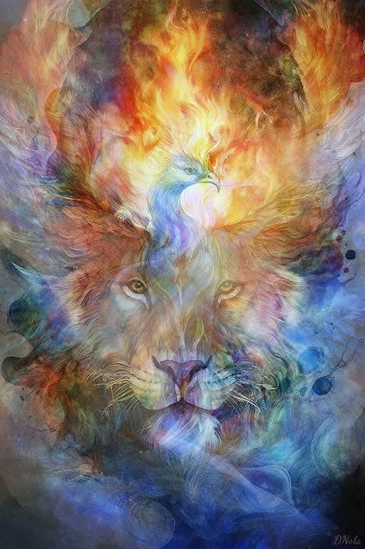

[Please put these as rectangles side by side, if there is space on the page; if not, then one under the other]

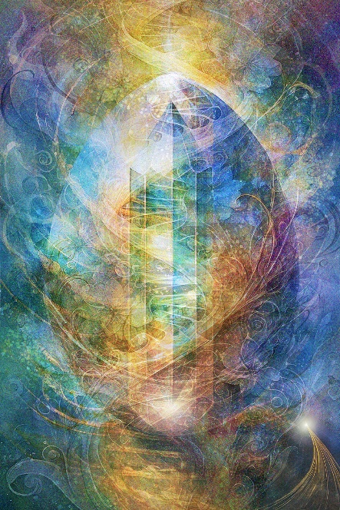

Book an in-person healing session
(1,5 hours; £120)

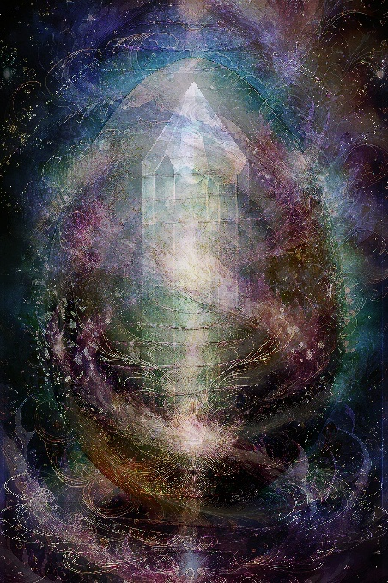

Book a distant healing session
(1 hour; £80)

[Carousel with testimonials; to be added when I get them 😊]

[Contact page]
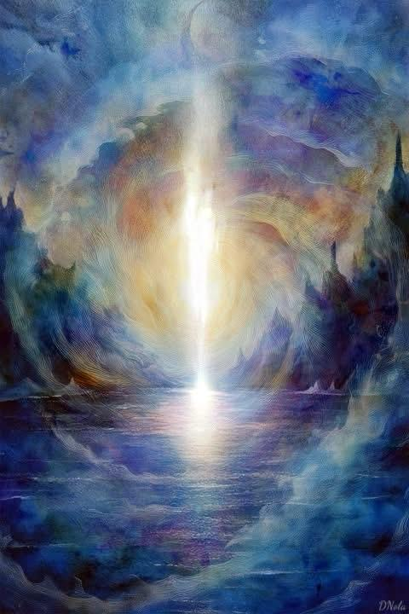
[Contact Me form here with ‘Name’, ‘Email Address’, ‘Phone Number (optional)’, and ‘Message’ text boxes, with the ‘Submit’ button underneath]

Contact Info
WhatsApp: +44 77 888 47 113
Email: contact@tesoulra.com
[FB icon] [Instagram icon]

